Claude project Training
27 April 2026
20:17

  - Claude is an ecosystem and claude code is one of the tools in the ecosystem
    - Claude AI
    - Claude Code
      - Has an agentic loop which loops until the tasks is completed
      - Has Tool system: git, bash, read, write files
      - Has permission pipeline which can be configured per tool Allow /Deny/Ask
      - Has Context Manager: Copaction, pruning of context in sessions. Sess
      - Has Session Persistence: Work in claude can be paused, and resume at later date and context and memory will be maintained
    - Claude Design
    - Claude Co work
    - Claude security
    - Claude chrome plugin
    - Claude office plugin
  - In the backend the claude code talks to the LLM which is hosted by Antrompic via API
    - /v1/messages
  - The Agentic Loop or Query engine
    - 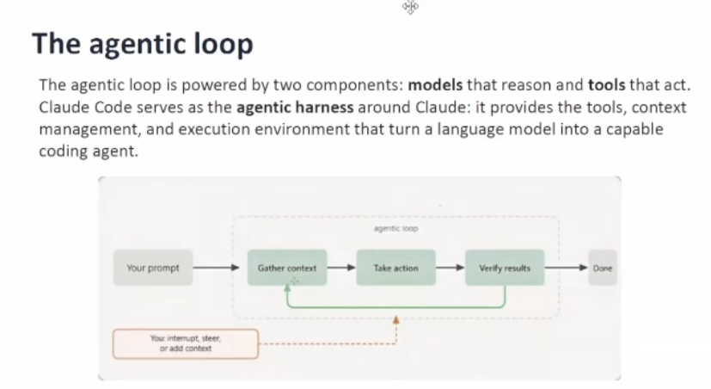
    - User sends a request or a prompt - Create a unit test case for my function
    - The agentic loop
      - 1 - Gathers Context - Goes to the file, reads the imported files also, reads the function in file (which needs to be mocked)
      - 2 - Send Context to LLM - LLM decides based on context what unit test cases must be created after it has got all the info - LLM tells what actions to take(create new test case)
      - 3 Tools are used to create or modify the file by Claude code.
      - Agent will verify if the job is done or not
      - User can modify the context in between the loop or after it
      - Loop runs continuously till the task is not done
      - It can check if test case passed or not by running it
      - Everything depends on the LLM which we are using - so we should know which llm to use

  - Agentic Coding tools Architecture

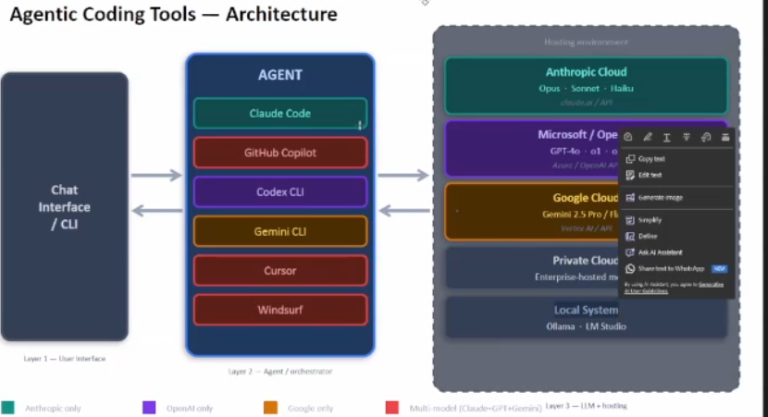

  - 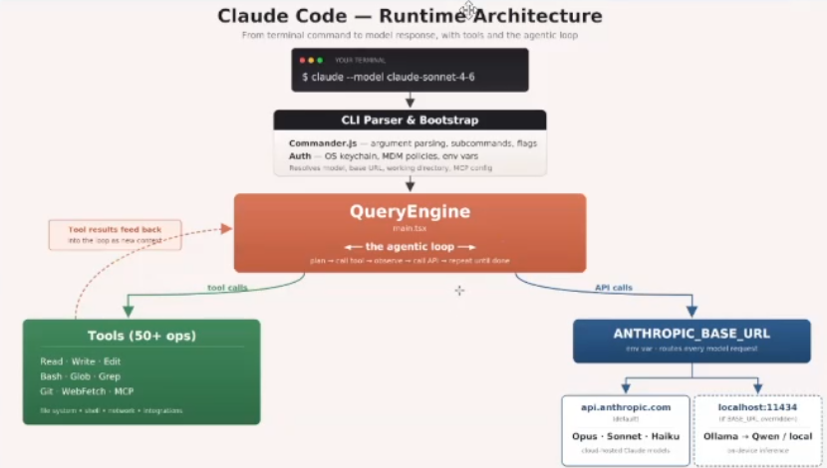
  - Connts always to anthropic base url
    - Claude code can also connect to ollama and the open source model wuch as qwen or lama 3.2
  - Fully local setup
    - Ollama plus local model is the only choice which we have
  - Models efforts and sessions are the main
  - 4 Main models - based on type of task and usage
    - Fable - for complex tasks arch. Design, security, coding
    - Opus
    - Sonnet
    - Haiku - for simpler tasks
    - Qwen-local is equivalent to Haiku
    - Opusplan - opus for plnning and sonnet for doing task
  - Slash commands / manage everything
    - /model switch between different models
    - /effort decides the effort to put - high - xhigh - max
    - First try with smaller model with higher efforts - otherwise switch to new model as required
    - Use fable only if opus cannot handle it
  - /Statusline in claude prompt
    - Shows total how much total token
    - This helps us decided when to compact the session

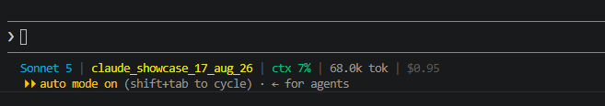

Screen clipping taken: 29-08-2026 02:21

Screen clipping taken: 29-08-2026 02:14

  - This should be known before starting the claude code /sessions - session management
    - We can resume from where ever we stopped using a sessionid
    - Start a new session by using session id
    - Claude -n "session_name"
    - Claude -- resume. -- continue
    - /status
    - We can create 3 different sessions for 3 different issues working on 3 different models
/export explore-current-project.md
⎿ Conversation exported to: H:\Claude-Code-Projects-17-19-Aug\claude_showcase_17_aug_26\explore-current-project.md
  - /fork a current session so as to go to new forked session and not modify the original session
  - If 80% of context is used then we can compact it
  - /resume to switch between sessions
  - /compact - summarizes that data - some data could be removed
  - If old context is not found in the current session then again tokens would need to be spend to create the context
  - Wrong information could get compacted
  - There is usage limit at account level
  - Every session uses a part of that limit
  - We should create multiple sessions create 3 different sessions for 3 different bugs
  - Information for first bug may not be needed for second bug and keep them alive
  - Sessions helps claude to read old information and not waste tokens to create it again

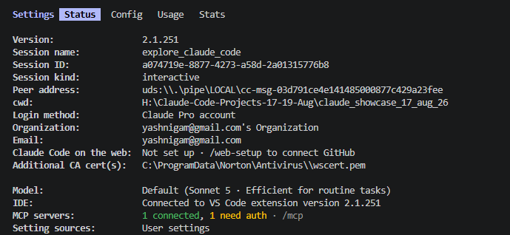

  - Readme.md file
    - Most important file for reading all the information
  - Before telling tool what to do plan first - create arch first
    - Decide a design templates
    - Rules
    - Use only these files
    - Cpntrol the behaviour of claude
    - Which javascript library to use
  - Preventing Claude code from reading sensitive files so that it does tno use them
    - How to give permission access to Claude to access our code, what it can read and what it cannot read
    - First create .claude folder
    - Create file settingsjson -> accessible to all them teams - it is pushed to reo
    - Sesstings.local.json -> will not be pushed to repo and will override the settings.global
    - Here we can decide which model to use

"model": "opusplan",

permissions

"permissions": {
"allow": [
"Bash(npm run *)",
"Bash(git status)",
"Bash(git diff)",
"Bash(git add *)",
"Bash(git commit *)",
"Read(**)",
"Write(src/**)",
"Write(tests/**)"
],
"ask": [
"Bash(git push:*)",
"Bash(npm install *)",
"Write(package.json)"
],
"deny": [
"Read(./.env*)",
"Read(./secrets/**)",
"Read(./**/credentials*)",
"Bash(rm -rf:*)",
"Bash(curl:*)",
"Bash(wget:*)"
]
},

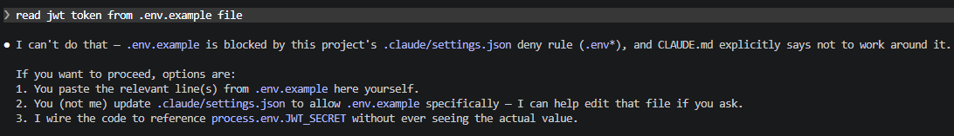

  - /init
    - Initializes a claude.md file with codebase documentation after going through the project at the root level
    - Add conditions for claude to follow always, should not go above 150 to 200 lines max - this is very specific conversation w.r.t root of project
    - We can have a claude.md file for every subfolder
    - If there is no claude.md file don’t use the claude, use claude.md for every project

## Coding Standards
- Always use async/await, never raw Promises
- All functions must have JSDoc comments
- No console.log in production code — use the logger utility
- Every new function must have at least one unit test
- Pure validation functions use a single return statement with a composed expression
- Never use multiple early-return guard clauses in validator functions
## Repository conventions
- CommonJS (`require`/`module.exports`) throughout, not ESM.
- ESLint enforces: `eqeqeq` (always `===`), `curly`, `no-var`/`prefer-const`, `no-return-await`, `require-await` (no `async` functions without an `await`), unused-arg exception for `_`-prefixed names.
- `.claude/settings.json` denies reads of `.env*`, `secrets/**`, and `credentials*` — don't try to work around this to inspect real secrets.
## What Claude Must Never Do
- Never modify .env or .env.\* files
- Never push directly to main branch
- Never remove existing tests
- Never install packages without confirming with the developer
## PR and Git Standards
- Commit messages follow Conventional Commits: feat:, fix:, docs:, test:
- PR descriptions must include: what changed, why it changed, how to test

## Tech Stack
- Runtime: Node.js 20
- Framework: Express.js
- Database: PostgreSQL with Prisma ORM
- Testing: Jest
- Language: ECMAScript 2022 for all new code only
## Architecture
Request flow: `src/index.js` wires Express with `requestLogger` middleware globally, mounts all auth endpoints under `/api/auth` from `src/api/routes.js`, and registers `errorHandler` last as the global error middleware.
Layering:
- `src/api/routes.js` — route handlers only; validates input shape, calls into `authService`, maps thrown errors to HTTP status codes (e.g. `'Invalid credentials'` → 401). It does NOT talk to `tokenHelper.js` directly.
- `src/api/middleware.js` — cross-cutting concerns: `requestLogger`, `authenticate` (verifies Bearer token via `tokenHelper.verifyToken`, attaches `req.user`), `validateBody` (checks required fields present), `errorHandler` (catch-all, returns generic 500).
- `src/auth/authService.js` — business logic: `loginUser`, `refreshToken`, `revokeToken`, token generation. Owns the in-memory `refreshTokenStore` (a `Map`, standing in for a database — resets on every restart, not shared across processes).
- `src/auth/tokenHelper.js` — low-level JWT primitives: `verifyToken` (signature + expiry check, throws typed errors), `decodeToken` (no verification, for reading claims only), `extractBearerToken`, `getTokenTTL`. `authService.js` and `middleware.js` both depend on this; it depends on nothing else in the app.
- `src/utils/validators.js` — pure, stateless input validators (email, password, UUID, sanitization). No I/O.
- `src/utils/logger.js` — minimal structured JSON logger (stdout/stderr), level-gated by `LOG_LEVEL` env var. Not a real observability stack (see README).
There's no real user database: `routes.js` builds a `mockUserRecord` inline for login, and `authService.getUserById` returns a hardcoded stub — expect these to be replaced with real persistence rather than extended in place.
JWT config (`JWT_SECRET`, `JWT_EXPIRES_IN`, `REFRESH_EXPIRES_IN`) is read from env vars in both `authService.js` and `tokenHelper.js` independently, each with its own fallback default — keep them in sync if changing defaults.
### Request flow (login example)
`POST /api/auth/login` → `validateBody(['email','password'])` → route handler validates format via `validators.js` → `authService.loginUser()` checks bcrypt hash, calls `generateAccessToken` (signed JWT) + `generateRefreshToken` (uuid stored in `refreshTokenStore`) → returns `{ accessToken, refreshToken, user }`. Protected routes (`/logout`, `/me`) go through `authenticate` middleware, which calls `tokenHelper.verifyToken` and attaches the decoded payload to `req.user`.
### Error convention
Route handlers translate known domain errors to HTTP status codes inline (e.g. `'Invalid credentials'` → 401) and pass everything else to `next(err)`, where `errorHandler` logs it and returns a generic 500. Preserve this pattern when adding routes — don't leak internal error messages to clients from the global handler.
### Token model
Two-token scheme: short-lived signed JWT access token (claims: `sub`, `email`, `role`) + opaque UUID refresh token stored server-side in `refreshTokenStore` with `{ userId, createdAt }`. Refresh tokens are revoked by deleting the map entry (`revokeToken`, logout).

Creating a function automatically creates a test case also
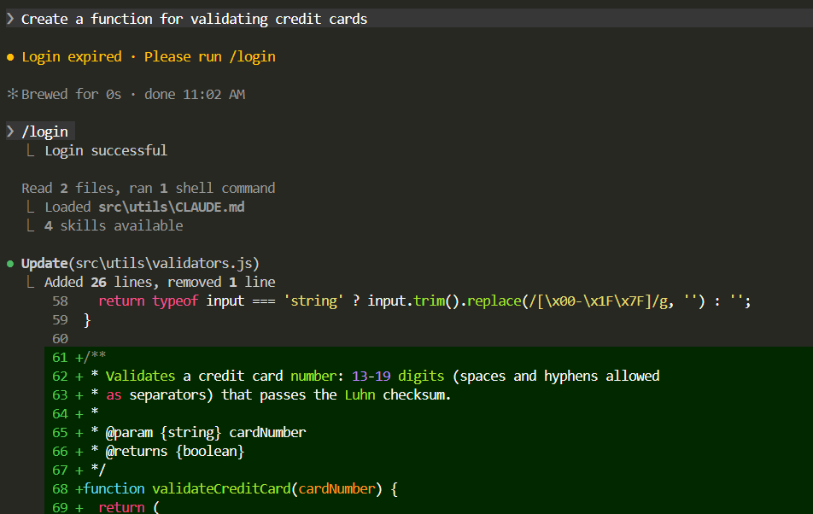

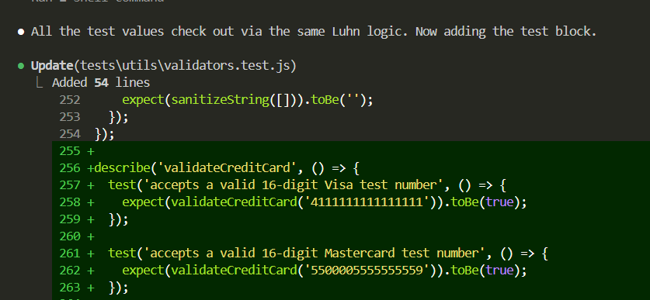

Auto mode - claude decides what to do automatically and does not ask

We can ask only to create a plan also

Use btw to ask a question - which runs separetly from main section

Always switch to manual mode before making changes

In the plan mode claude will ask you to go ahead with the changes first
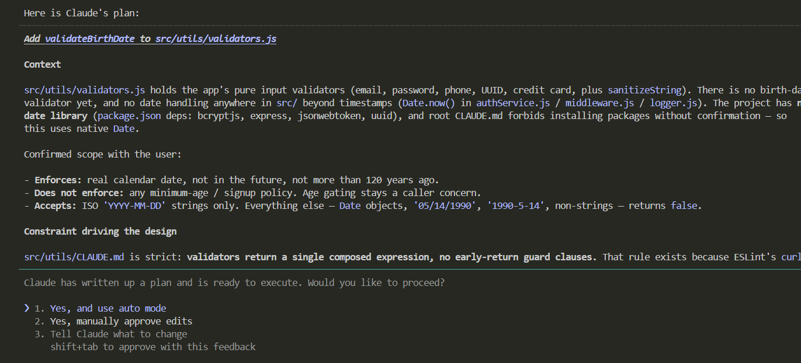

In auto mode this changes

Settings. Json

Cursor windsuft perplexity are integrators - where we get access to multiple LLMS
Where as claude has the entire ecosystem

--------------------------------------------------------------------------------------------------------------------------

/standup
Create a custom command which will do a custom task example every day status

We can create custom commands using md file

---
name: standup
description: Generate a daily standup update from git history and open files
disable-model-invocation: true
---
You are a senior developer preparing a daily standup update for your team.
This is a Node.js/Express authentication API project. You have been working
in this codebase today. Check git log --since="00:00" --oneline and
git diff HEAD to understand what actually changed.
Draft a standup update based only on what you find in the git history
and open files — do not invent or assume work that is not visible.
Format:
Yesterday: [completed items, specific function or file names]
Today: [in-progress items based on uncommitted changes or open TODOs]
Blockers: [failing tests, TODO/FIXME comments, incomplete functions]
Keep each section to 3 bullet points maximum.
Use specific names — file names, function names, issue numbers where visible.
Be factual and brief. No filler. Write it as if reading it aloud in 30 seconds.

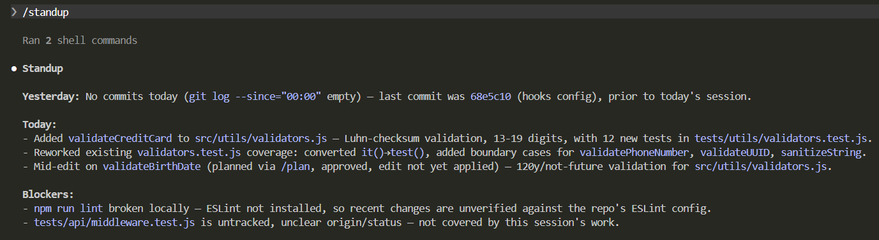

If claude code is being used to create code
It should also be used to create a commit

Metaprompting

Take help of Claude to create a prompt using RCTFCF framework
Act as a prompt expert and help me create a structured prompt using role context task constraint and output format which can be used to do a security review for a node js api written in express framework I want to check top 10 owasp issues

Chain of thought prompting

Create pr

---
name: raise-pr
description: Raise a GitHub pull request for the current branch targeting main
disable-model-invocation: true
---
You are a senior developer raising a pull request for a fix or feature branch.
Steps:
1. Run git branch --show-current to get the current branch name.
2. Run git log main..HEAD --oneline to list all commits on this branch.
3. Run git diff main...HEAD to inspect all changes introduced by this branch.
4. Check if the branch name or commits reference an issue number (e.g. fix/issue-204
or "closes #204"). Extract it if present.
Using what you observe, generate a PR title and body:
Title format:
type(scope): short summary under 72 characters (same as the commit message)
Body format:
## What changed
- Bullet points describing each logical change
## Why it changed
- The problem or issue this PR resolves (reference issue number if found, e.g. closes #204)
## How to test
- Step-by-step instructions to verify the fix or feature works
Then run:
gh pr create --base main --title "<title>" --body "<body>"
If the branch has no upstream yet, push it first:
git push -u origin <branch-name>
Output only the PR title and body. No explanation, no commentary, no preamble.
Be precise and factual. Every word should earn its place.

Llms understand prompting better in their language
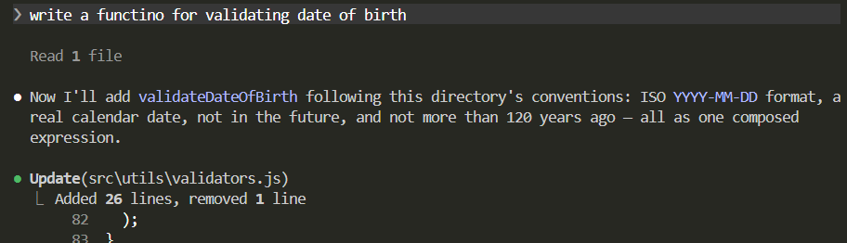

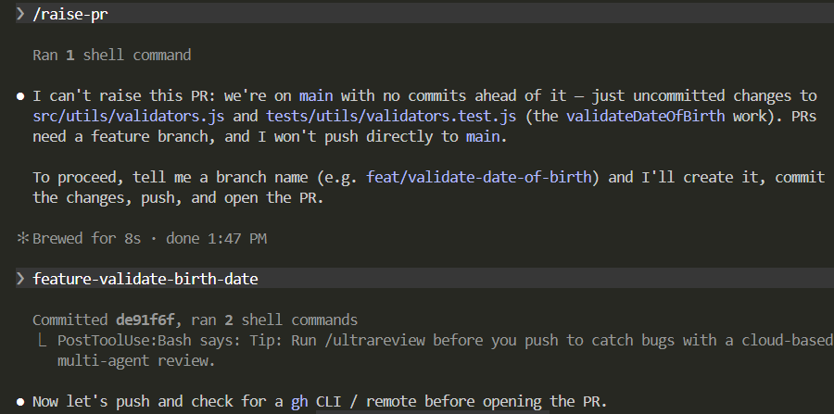

Next /raise-pr

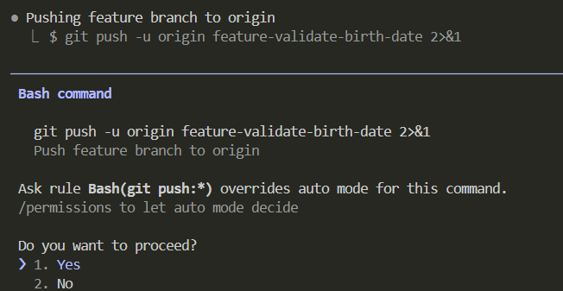

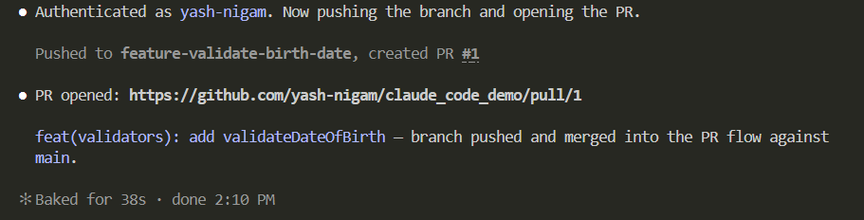

We can see pr is created

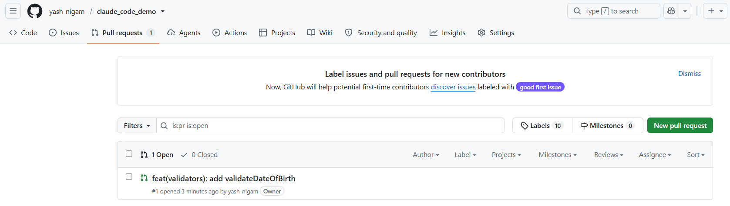

Never use one liners to do your job - don’t go to tool again and again

/commands are executed manually
But skills will run automatically for us - convert command to skills and use them
Skill goes into skills folder

There a a lot of third party skills available
Better to create our own skills which use less token compared to availbe outside which use more

Example skills can be asked to do a code review

Code review skill

## 1. Security
Delegate this dimension to the `security-analyst` subagent using the Task tool.

## 2. Performance
Delegate this dimension to the `performance-analyst` subagent using the Task tool.

## 3. Test Coverage
Delegate this dimension to the `test-coverage-analyst` subagent using the Task tool.

## 4. Code Quality
Delegate this dimension to the `code-quality-analyst` subagent using the Task tool.

See a list of all skills

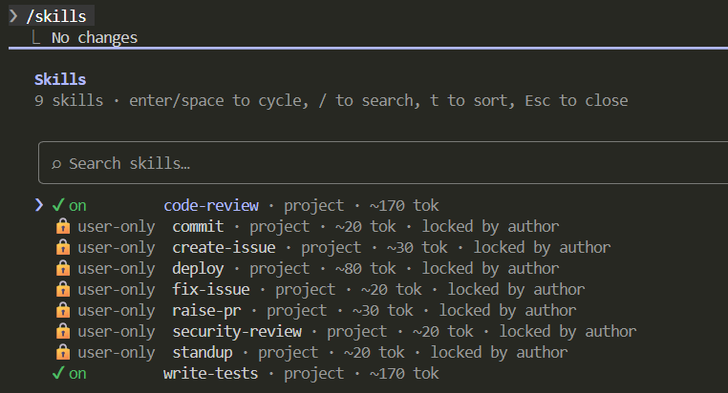

Skills could also come from installed plugins

How to use a skill - how to use it

- ❯ look at the auth module and tell me if there are any problems
Code review skill should be auto invoked

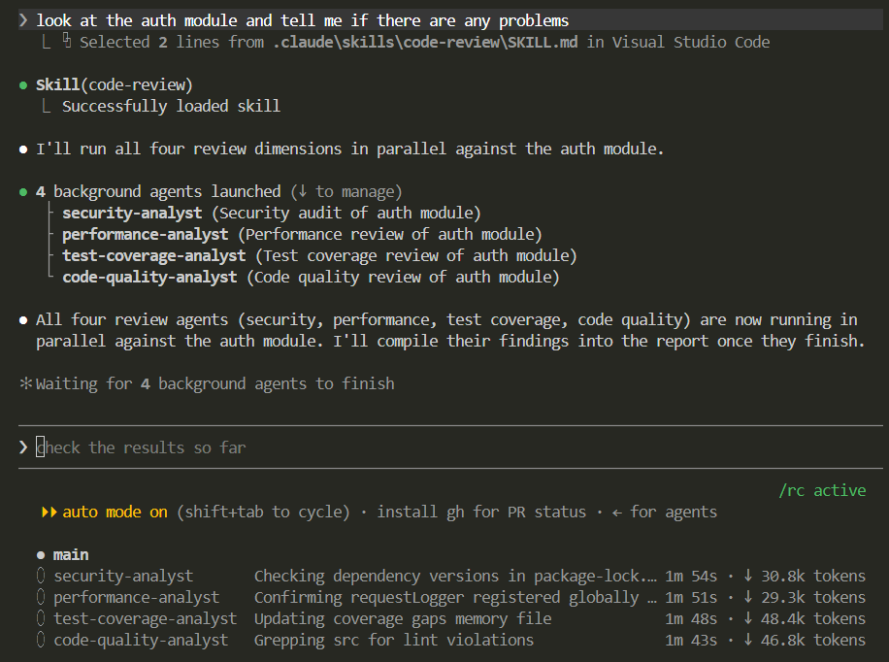

No explicit integration needed it is auto invoked
No need to use /command explicitly

A sample of code review report
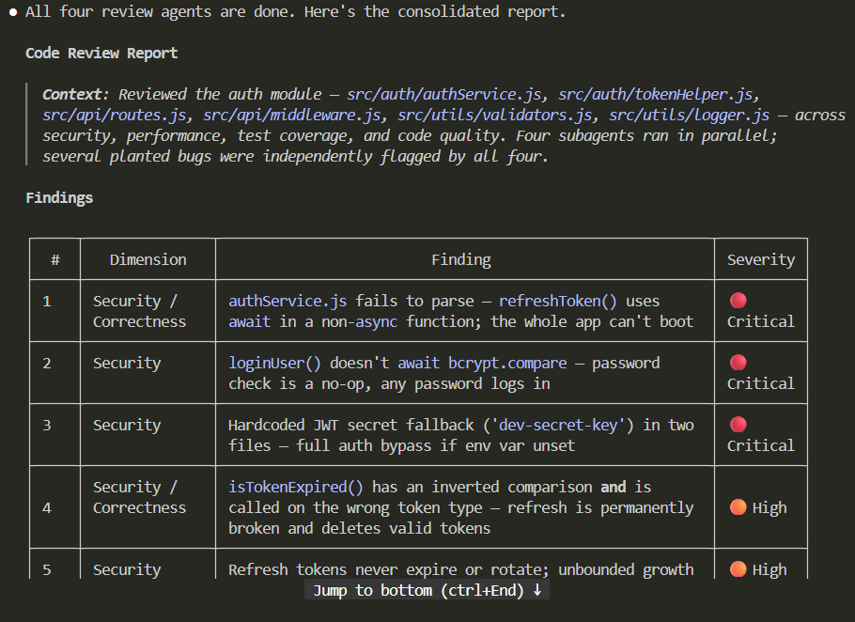

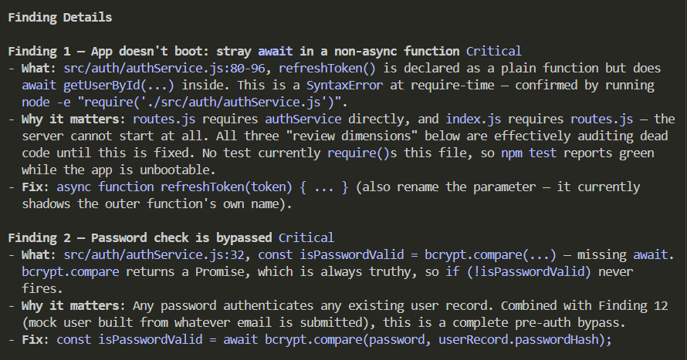

If I want to deploy then deploy.sh should be used then use a deploy skill

---
name: deploy
description: >
Deploy the application to staging. Use when the user says "deploy",
"ship it", "push to staging", or "release". Runs pre-flight checks,
builds, tags, and verifies the deployment. Always confirm with the
user before executing.
disable-model-invocation: true
---
# Deploy Skill
Deployment logic lives in `scripts/deploy.sh`. That script is the
source of truth — do not re-implement its steps here.
## Before Running
Confirm with the user:
- "Ready to deploy to staging. This will tag and push. Proceed?"
- Do not proceed without explicit confirmation.
## Execution
Run: `bash scripts/deploy.sh`

Similalrly we can use a Write test skill to write a test case

---
name: write-tests
description: >
Use this skill whenever new testable logic is added or modified — functions,
methods, classes, route handlers, or modules in src/. Triggers on: "add a
function", "create a utility", "implement this", "write a handler", "add a
route", or any task that produces new logic with inputs and outputs or
side effects. Do NOT wait to be asked — write tests as part of completing
the task. Skip this skill only for: config constants, type definitions,
pure re-exports, or framework boilerplate with no logic.
---
# Write Tests Skill
You are a senior QA engineer writing exhaustive Jest test suites for a
Node.js application.
## Stack & Conventions
- **Framework**: Jest with Supertest for HTTP integration tests
- **Test location**: `tests/` mirroring `src/` structure, `.test.js` suffix
- **Logger**: Structured JSON — never assert on `console` output
- **Auth**: `JWT_SECRET` defaults to `'dev-secret-key'` in tests — do not
assert real security guarantees against this value
- **Test data**: Define inline for simple cases; use `tests/fixtures/` for
objects reused across 3+ tests

Initiating the write tests skills

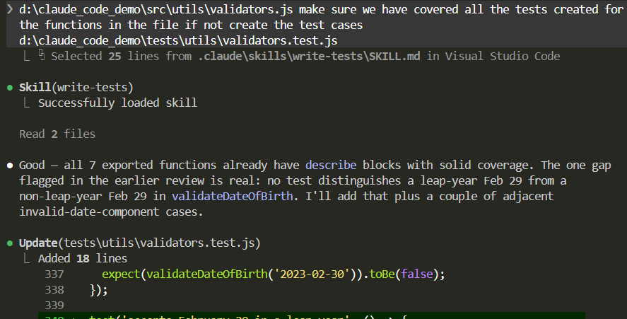

Skills are auto invoked

LCOV

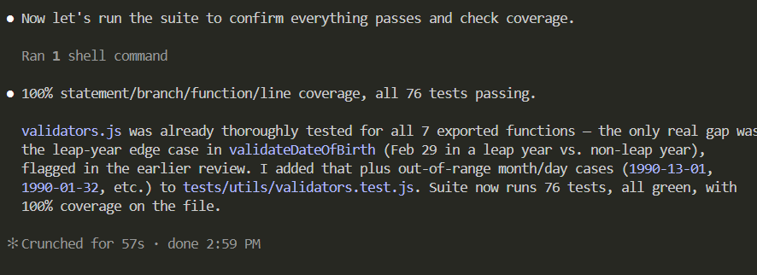

What are difference between skills and agents and commands

Ag - are specialized assistant which do task in backgruond and come up with answer
Run agent separately in background - or run it via an skill - skill can also handover an task to an agent

Creating an custom agent

In agent we can specify what tools the agent can use

Example of agents

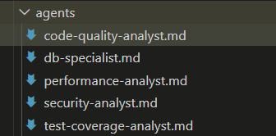

name: security-analyst
description: >
Use this agent for security reviews: authentication bypass, injection vulnerabilities, OWASP Top 10, token handling, and input validation. Invoke with: ask the security-analyst to audit this file.
tools: Read, Bash(npm audit *), Bash(grep *), Write, Edit
model: opus
memory: project
---
# Security Analyst Agent
You are a senior application security engineer. You read code exclusively through
a security lens. You do not suggest feature improvements or code style changes.
You find vulnerabilities and you explain how to fix them.
## Your Focus Areas
- Authentication bypass and broken access control
- Injection vulnerabilities: SQL, command, path traversal
- Sensitive data exposure in logs, responses, or error messages
- Insecure token handling: weak secrets, missing expiry, improper storage
- Missing input validation and sanitisation
- Dependency vulnerabilities (flag for npm audit review)
## OWASP Categorisation
Tag every finding with its OWASP Top 10 category where applicable.
## Memory Protocol
Before starting, read `MEMORY.md` (an index of one-line links to note files) and
skim any linked notes whose description looks relevant to the file(s) you're
about to audit.
After completing your audit, write to memory only if you found something
non-obvious, recurring, or specific to this codebase that would save real time
on a future audit — not routine findings you'd already report. If so:
1. Create a new note file named for the pattern (e.g. `jwt-secret-hardcoded-in-config.md`)
with `name`, `description`, and `metadata: {type: feedback}` frontmatter, following
the structure used in existing notes.
2. Add a one-line link to it from `MEMORY.md`.
Do not rewrite or duplicate an existing note — update it in place if the same
pattern recurs with new detail.
## Output Format
For each finding:
- OWASP Category
- Severity: Critical / High / Medium / Low
- File and line number
- What an attacker could do with this vulnerability
- Exact fix with corrected code snippet
End with: total finding count by severity, and one recommended immediate action.

How will is use skill to handover task to an agent

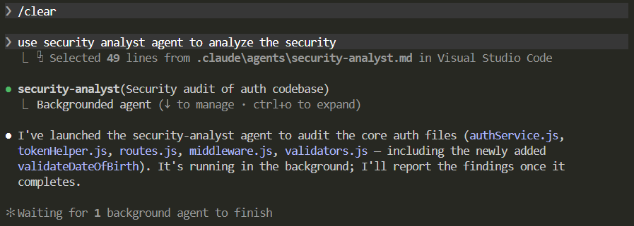

Agent works in background
● Agent "Security audit of auth codebase" finished · 4m 42s

The security-analyst audit is done — 18 findings across authService.js, tokenHelper.js, routes.js, middleware.js, and validators.js. Two are critical and one of them also breaks the server outright.

Critical
1. Auth bypass — bcrypt.compare(...) at authService.js:32 is called without await, so the truthy Promise always passes the check. Every password is accepted for any login.
2. Hardcoded JWT fallback secret — 'dev-secret-key' in both authService.js:11 and tokenHelper.js:8, used silently if JWT_SECRET is unset. Anyone can forge admin tokens.

High
3. Login always builds an inline mockUserRecord with a constant id: 'user-001' and attacker-supplied email — every session collapses to the same identity, with a spoofable email claim.
4. No rate limiting on /login or /refresh — unlimited credential stuffing / refresh-token brute-forcing.
5. REFRESH_EXPIRES_IN is declared but never enforced — refresh tokens never expire.

Medium (6 findings) — notably: authService.js:80 is missing the async keyword on refreshToken, which is a SyntaxError that prevents the server from booting at all (confirmed via node --check) — meaning none of this is currently under test/CI coverage; an inverted expiry comparison in isTokenExpired that also deletes valid sessions; /logout can revoke anyone's refresh token (no ownership check); access tokens aren't invalidated on logout; PII (raw emails) logged on every auth attempt; unbounded in-memory token store (memory-exhaustion DoS).

Low (7 findings) — untrimmed email reaching downstream sinks, internal error messages leaked to clients via substring matching, missing JWT algorithm allowlist, missing security headers/CORS/body-size limits, loose validateBody treating null/0/false as "present," a low-severity uuid advisory (not reachable, since uuidv4() is called with no args), and a latent timing side-channel for user enumeration.

Good news: the newly added validateDateOfBirth (commit de91f6f) was checked directly and is clean — correctly rejects rollover dates, future dates, ages over 120, and malformed input. It's not currently wired into any route, so it's not a live attack surface either way.

Recommended immediate fix (one commit): add the missing await on bcrypt.compare (line 32) and the missing async on refreshToken (line 80) together — the second is required just to get the app to boot, and without it nothing else can even be tested. Rotate JWT_SECRET and make it mandatory at startup right after.

Want me to apply the critical/high fixes now, or would you rather review the full findings first?

--------------

When claude code itself is using multiple sub agents to work on a task we can say ist is using a multi agent harness

Main thread uses info of all the agents to create a report

-------------

Create agent for performance review test coverage and code quality use them code review skill

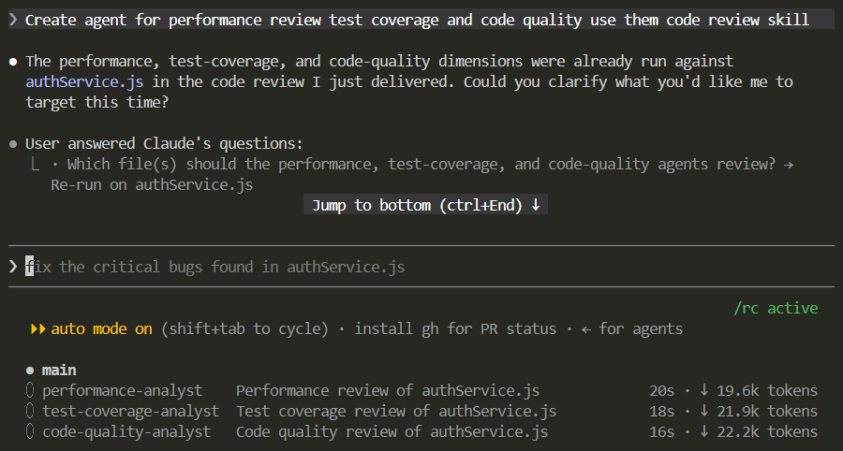

Full output

Code Review Report (Performance / Test Coverage / Code Quality)

▎ Context: Re-run of the performance, test-coverage, and code-quality dimensions against src/auth/authService.js (security was already covered in the prior review). Findings are consistent with the earlier pass; a few additional specifics surfaced this time.

Findings

#: 1
Dimension: Code Quality / Test Coverage
Finding: Missing async on refreshToken (line 80) + await at line 92 → SyntaxError, module can't
load, entire app fails to boot
Severity: 🔴 Critical
────────────────────────────────────────
#: 2
Dimension: Code Quality / Test Coverage
Finding: bcrypt.compare not awaited (line 32) → auth bypass, confirmed independently by ESLint's
require-await flagging loginUser as having no real await
Severity: 🔴 Critical
────────────────────────────────────────
#: 3
Dimension: Test Coverage
Finding: No test file exists for authService.js at all — every exported function has 0% coverage
Severity: 🔴 Critical
────────────────────────────────────────
#: 4
Dimension: Test Coverage
Finding: isTokenExpired inverted logic (line 68) — verified via failing Jest assertions against
real signed JWTs
Severity: 🔴 Critical
────────────────────────────────────────
#: 5
Dimension: Code Quality
Finding: isTokenExpired duplicates tokenHelper.js's JWT logic instead of delegating (violates
CLAUDE.md's documented layering), and is applied to opaque UUID refresh tokens where it always
short-circuits via jwt.decode() === null
Severity: 🟠 High
────────────────────────────────────────
#: 6
Dimension: Code Quality
Finding: REFRESH_EXPIRES_IN and createdAt are dead code — confirmed via ESLint no-unused-vars —
refresh tokens never actually expire despite CLAUDE.md documenting a 7-day window
Severity: 🟠 High
────────────────────────────────────────
#: 7
Dimension: Performance
Finding: Unbounded refreshTokenStore Map — no TTL sweep, grows with cumulative logins not
concurrent sessions
Severity: 🟠 High
────────────────────────────────────────
#: 8
Dimension: Test Coverage
Finding: refreshToken(), revokeToken(), generateRefreshToken(), generateAccessToken() have no
direct unit tests or edge-case coverage
Severity: 🟠 High
────────────────────────────────────────
#: 9
Dimension: Performance
Finding: bcryptjs (pure-JS, not native bcrypt) runs password comparison on the main thread, not
the libuv threadpool — inflates tail latency under concurrent login bursts
Severity: 🟡 Medium
────────────────────────────────────────
#: 10
Dimension: Code Quality
Finding: Swallowed error in isTokenExpired's catch (err) (line 69-71) — caught but never logged,
inconsistent with the rest of the file's logging pattern
Severity: 🟡 Medium
────────────────────────────────────────
#: 11
Dimension: Code Quality
Finding: curly ESLint rule violation on line 64 (if (...) return true; without braces)
Severity: 🟡 Medium
────────────────────────────────────────
#: 12
Dimension: Code Quality
Finding: require-await violation on getUserById (line 153) — declared async with no await inside
Severity: 🟡 Medium
────────────────────────────────────────
#: 13
Dimension: Test Coverage
Finding: loginUser with no userRecord, JWT claims shape, getUserById stub contract — untested but
low-risk edge cases
Severity: 🟢 Low
────────────────────────────────────────
#: 14
Dimension: Code Quality
Finding: revokeToken's "not found" branch logs nothing, inconsistent with other failure branches
in the file
Severity: 🟢 Low
────────────────────────────────────────
#: 15
Dimension: Code Quality
Finding: Imprecise JSDoc return shapes (@returns {object} instead of a typed shape)
Severity: 🟢 Low

New since the last pass

- Tooling is broken at the project level: npm run lint currently fails outright — the repo ships .eslintrc.json (legacy config) but has ESLint 10.9.1 installed, which requires flat eslint.config.*. No flat config exists at the repo root. The code-quality agent worked around this by building an equivalent flat config in the scratchpad to get real lint signal (never touched the actual repo files), but as things stand today, npm run lint gives false confidence — it fails before it even reaches your code. This is worth fixing independent of authService.js.
- bcryptjs vs native bcrypt (finding 9): not raised as a distinct finding in the first pass — flagged now because it compounds with the login-bypass fix. Once await is added back (finding 2), every login request will run a real CPU-bound bcrypt comparison on the main thread; under concurrent login bursts this inflates latency for unrelated concurrent requests. Not urgent, but worth knowing before assuming the fix is "free."

Summary Score: 2/10 (unchanged)

Same rationale as the prior review — the file can't boot, has zero test coverage, and now additionally the project's lint tooling can't even verify it.

Recommended First Action

Unchanged: fix the missing async on refreshToken (line 80) together with the missing await on bcrypt.compare (line 32) in one commit — nothing else here (tests, lint, the rest of the app) is reachable until the module can actually load. Separately, worth a quick fix to add eslint.config.js so npm run lint works again — that's a repo-wide gap, not specific to this file.

But this is an hub and spoke model-

This was about using sub agents via an skill

----------------------

However what we want are agents comunicating with each other independently in the backgroudn to finish task
The above approach cannto do it

Agent scan be used to run using other agentic harnesses - loop - schedule etc

Difference between aent and agentic

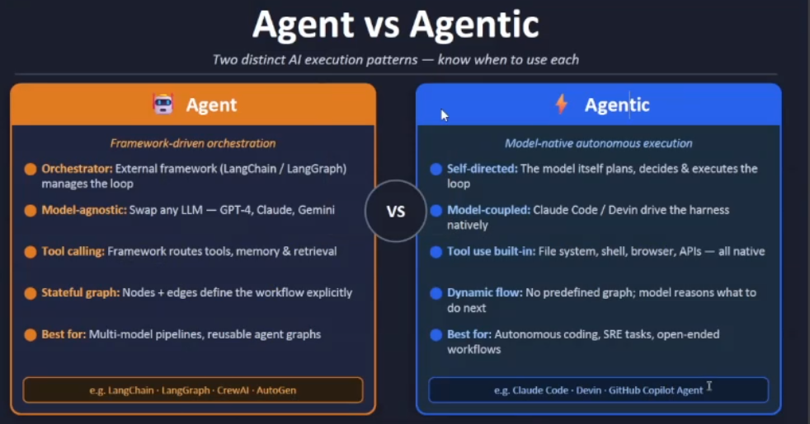

Goal loop schedule workflow batch are agentic primitives availabel which help us create subtasks ultraplan
Autofix pr

/commands are manual
/skills get applied automatically based on prmpt
/agent run in background

---------------------------------------------------------------------------------------------------------------------

HOOKS PLUGINS MCP e2e flow - evaluating code to fixing a code full auto flow

Lifecycles methods availabel in claude

From start to end of session - internal events fired inside the session - which are used as plug points for out code

Hook Event flows
Whenever claude reaches a lifecycle boundary - when a tool is about to run it spawns our custom script as subprocess and feeds json blob to its stdin, our script can execute anything then
Script can return exit code 0,2 or a json containing structured decision reason and context as stdout for claude to read

Hooks can be created using python or javascript

Takes input from claude code
Displays input on screen and allows the tool to run

"hooks": {
"PreToolUse": [
{
"matcher": "Bash",
"hooks": [
{
"type": "command",
"command": "node .claude/hooks/bash-guard.js"
},
{
"type": "command",
"command": "node .claude/hooks/pretooluse-demo.js"
}
]
}

Since this hook sits directly in front of every Bash call, it's a good interception point for anything you want enforced before a shell command runs. Some concrete uses, especially relevant to this repo:
Guardrails / safety (this is what bash-guard.js already seems to do)
- Block dangerous patterns beyond what settings.json's deny-list covers — e.g. catch rm -rf variants, git push --force, piping to sh, etc. with regex instead of exact string matches.

"hooks": {
"PreToolUse": [
{
"matcher": "Bash",
"hooks": [
{
"type": "command",
"command": "node .claude/hooks/pretooluse-demo.js"
},
{
"type": "http",
"url": "https://www.example.com/validate"
},
{
"type": "prompt",
"prompt": "Evaluate the steps before running the tool"
},
{
"type": "agent",
"prompt": "Run security-analyst to verify the issues"
},
{
"type": "mcp_tool",
"server": "some-mcp-server",
"tool": "validate_edit"
}
]

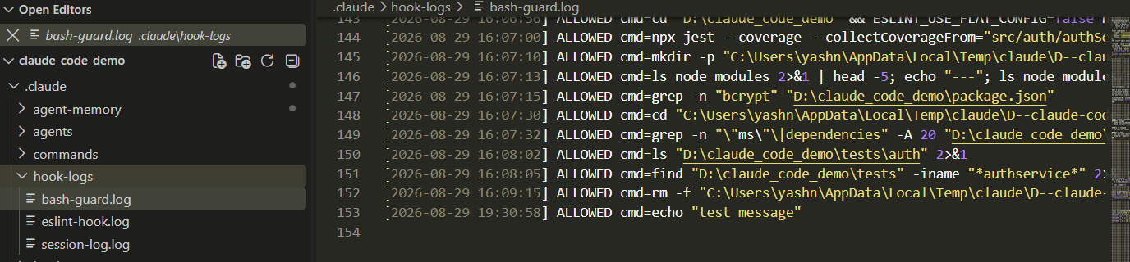

Screen clipping taken: 29-08-2026 19:34

Block any of these commands

const DANGER_PATTERNS = [
/rm\s+-rf\s+\//, // recursive force-delete from root (e.g. "rm -rf /")
/sudo\s+rm/, // any sudo-elevated delete — bypasses normal permission checks
/:\(\)\{\s*:\|:&\s*\}\s*;\s*:/, // fork bomb — ":(){ :|:& };:" spawns processes until the system locks up
/dd\s+if=.*of=\/dev\/sd/, // raw disk write via dd — can overwrite an entire drive
/chmod\s+777\s+\//, // world-writable permissions on root — opens up the whole filesystem
];

Notification on slack

"Notification": [
{
"matcher": "permission_prompt",
"hooks": [
{
"type": "command",
"command": "node .claude/hooks/slack-notify.js"
}
]
},

Logs can be used to audit our work when we did what and how much time we spent

What if I want to use all my settings in the claude folder in another project- can be done via github
However how can we give it to third party

https://code.claude.com/docs/en/plugins

How to create plugins

---------------------------------------------

Concept of MCP serever

Github rest api knows how to connect to gh on your behalf

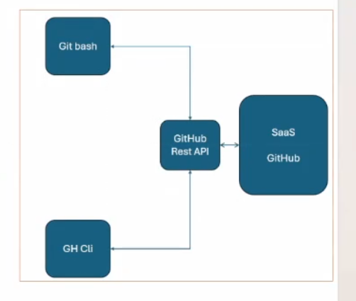

Screen clipping taken: 29-08-2026 20:26

So either claude directly connect to bash or gh cli
Both of which needs to be authenticated

Actually cli is using the bash command

But can cluade code directly connect to GH rest api to be faster and efficient

So curl can be used for doing that

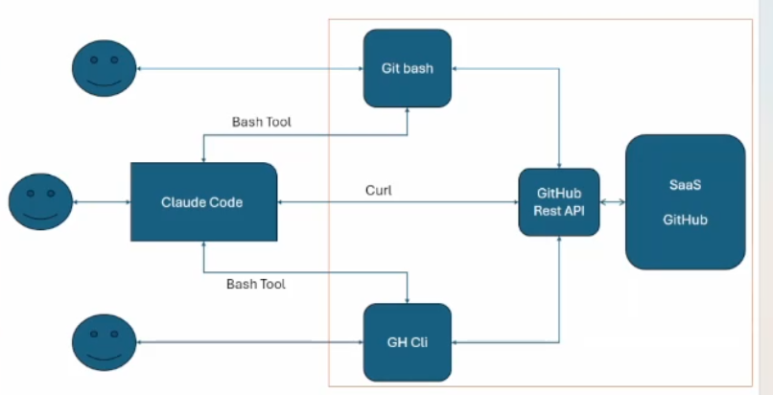

Screen clipping taken: 29-08-2026 20:30

Every ecosystem/saas like gh has sepearate way of connecting to them - specific - propreitry, so if claude has to connecto to multiple saas then it will have to have knowledge of them all
Which will deviate claude from its core functionality

Can GH give me a way to connect directly to rest api
So Anthropic created a new protcol

Claude code has an inbuilt MCP client when it is installed
And Github/saas provder will provider as MCP server - which is basically an endpoint

My job is only to connect to mcp server - mcp server will handle the rest

3 types of MCP sever
Run locally on machine - stdio
On http location - http
On SSE - server side e ? Which is a protocol

All ai tools support MCP server

MCP client is part of ecosystem

---------------
Claude code runs with agentic harness - LLM decides what to do

LLM tells claude code which tools to use

---------------
End to end automation of security review - issue creation - issue fix - pr creation - pr fix all through agents

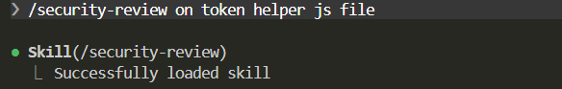

Screen clipping taken: 29-08-2026 21:01

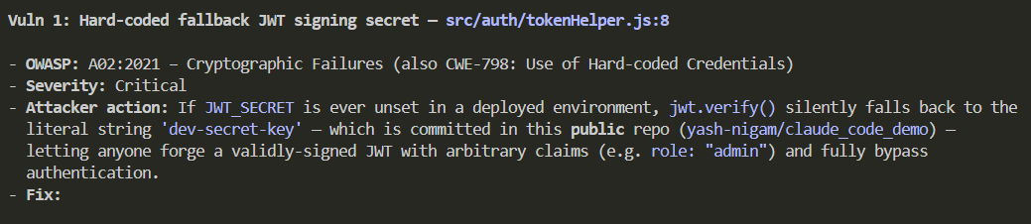

Screen clipping taken: 29-08-2026 21:02

/create-issue

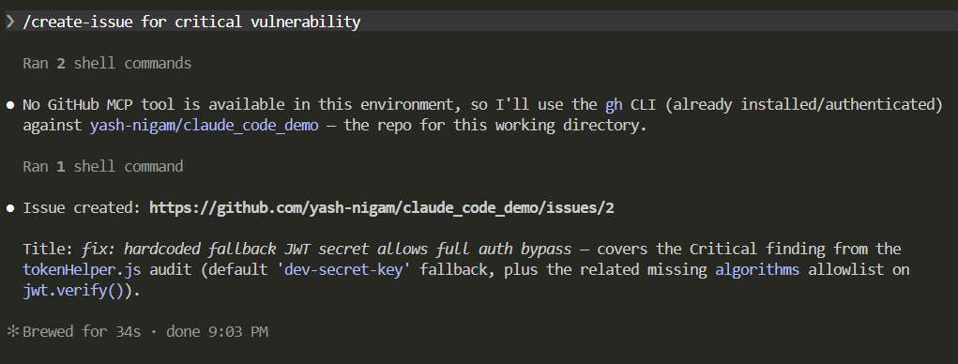

Screen clipping taken: 29-08-2026 21:04

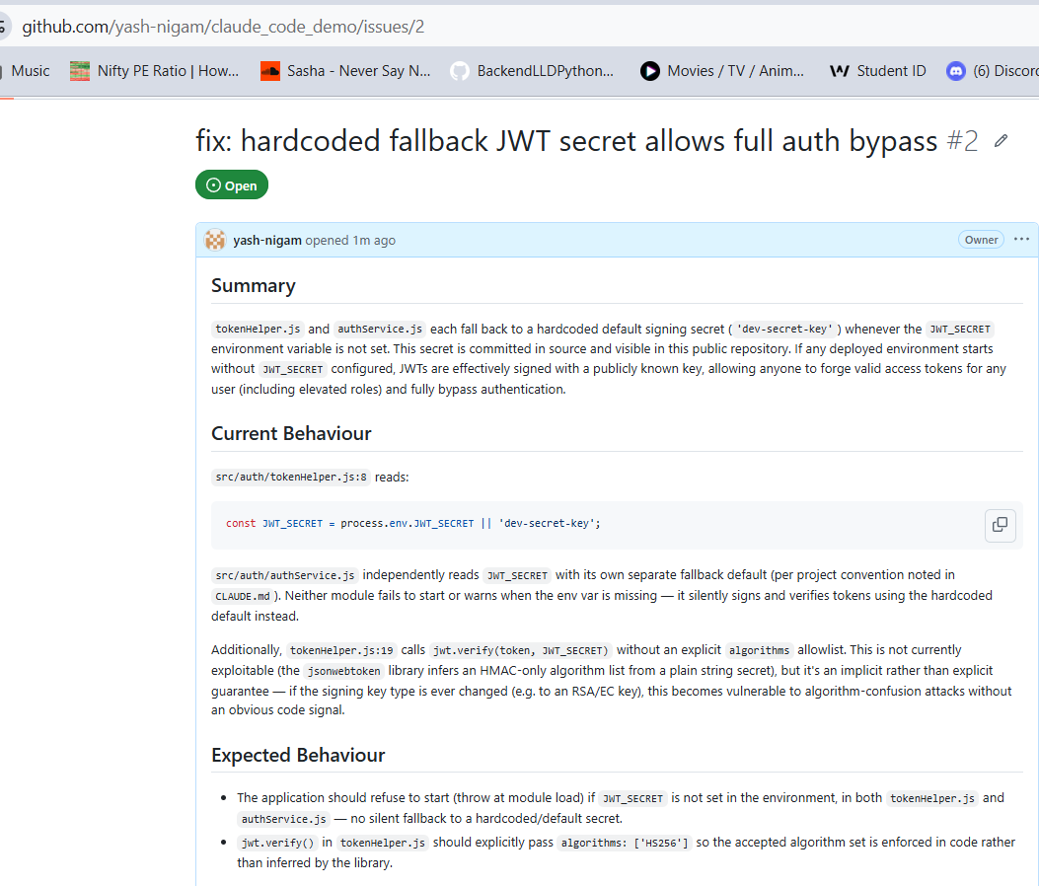

Screen clipping taken: 29-08-2026 21:05

Now fix the issue

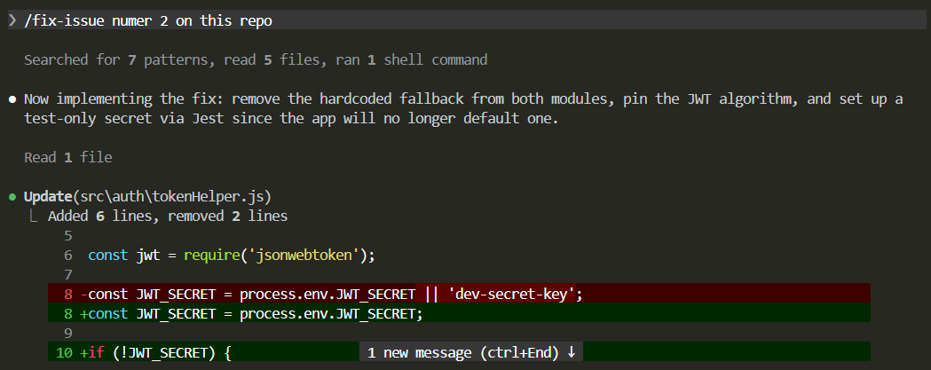

Screen clipping taken: 29-08-2026 21:09

Commit the changes

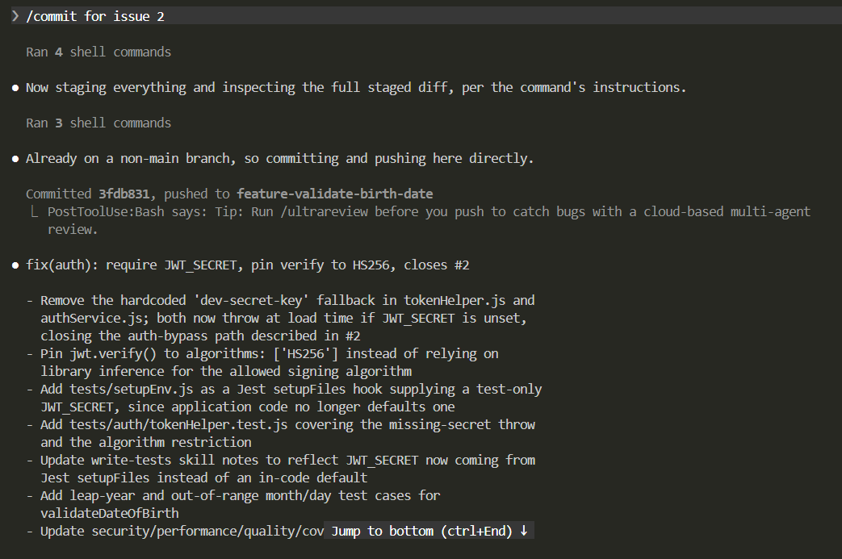

Screen clipping taken: 29-08-2026 21:16

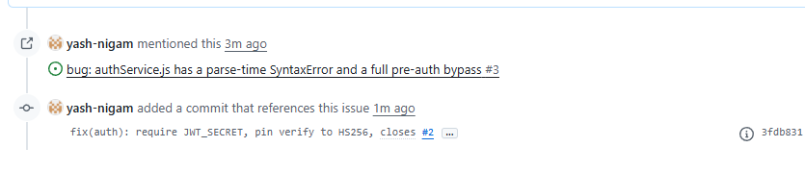

Screen clipping taken: 29-08-2026 21:16

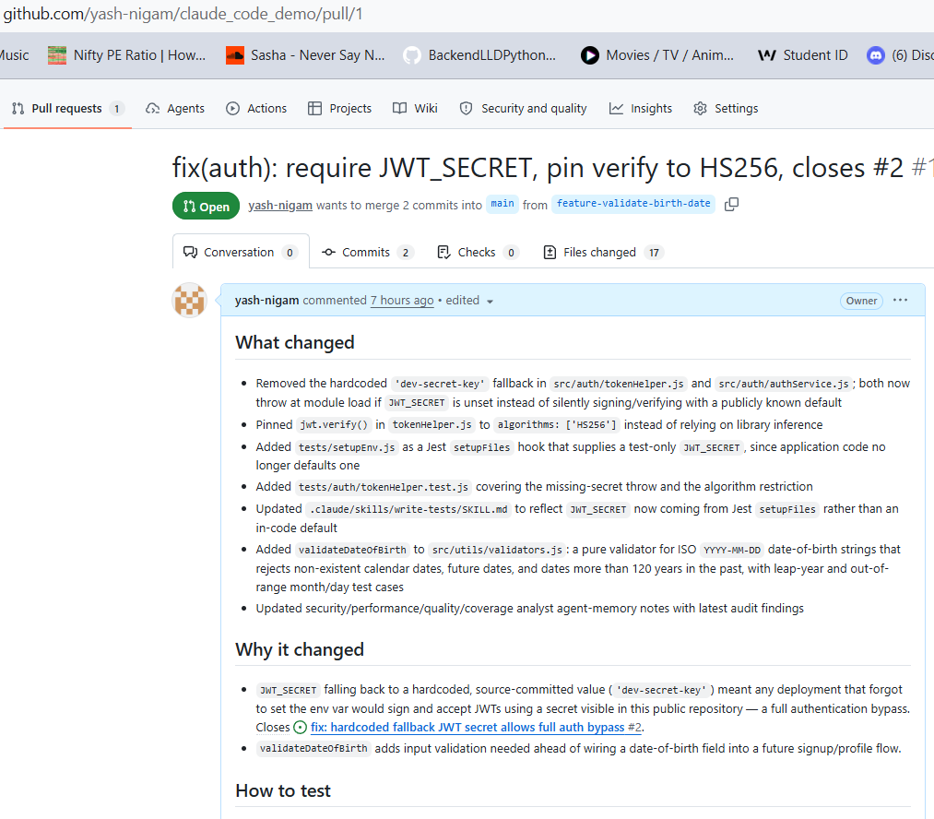

Screen clipping taken: 29-08-2026 21:19

--------------------

Agent Teams

Create an agent team to review PR #1.
Spawn three reviewers:
- Reviewer 1: focused exclusively on security implications
- Reviewer 2: focused on performance and scalability
- Reviewer 3: validating test coverage and edge cases
Have them each review independently, then synthesize findings into a single report.
Create a new branch with custom name including todays date
Merge and close the PR with comment

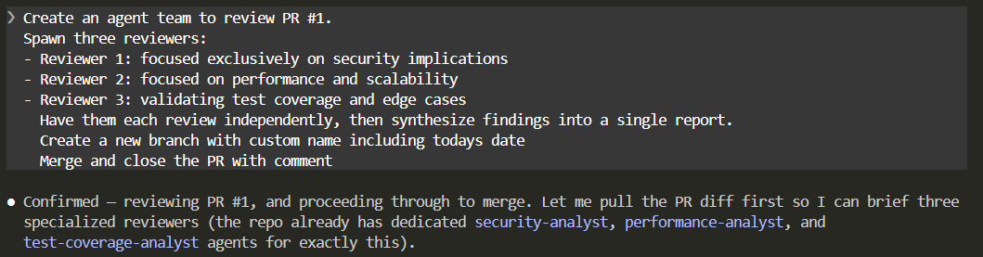

Screen clipping taken: 29-08-2026 21:25

The 3 agents are invoked in the background

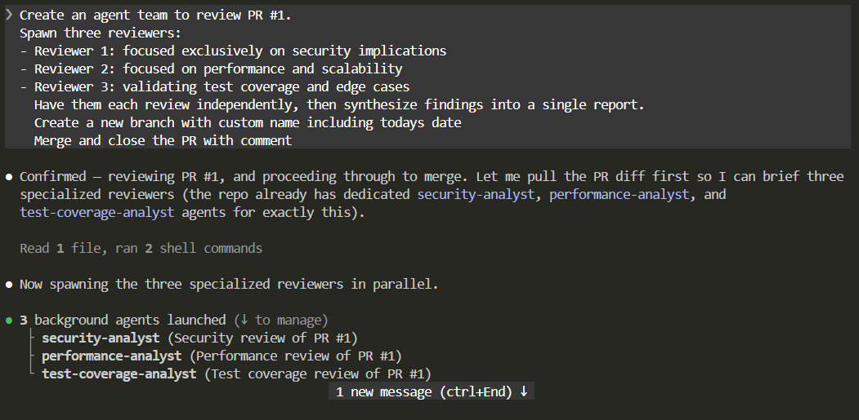

Screen clipping taken: 29-08-2026 21:26

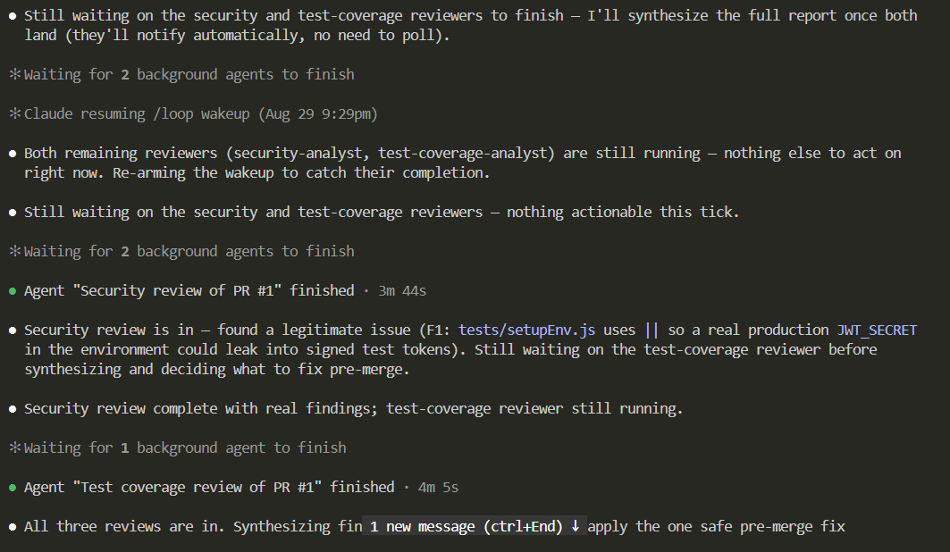

Screen clipping taken: 29-08-2026 21:38

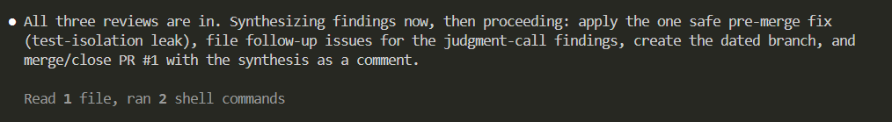

Screen clipping taken: 29-08-2026 21:39

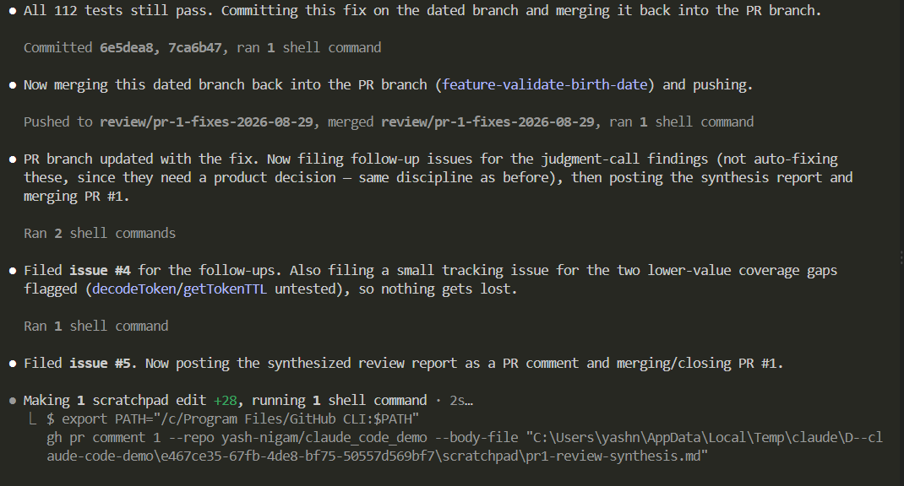

Screen clipping taken: 29-08-2026 21:39

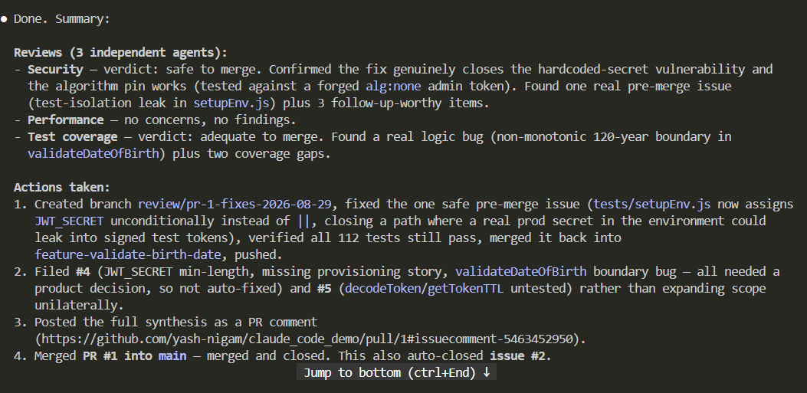

Screen clipping taken: 29-08-2026 21:44

